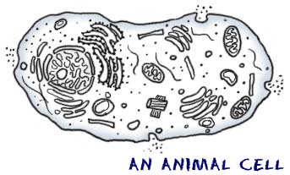
Name ________________________________________________________ Date __________________ Period _______
Cell Transport Webquest
Link 1 – Cell Transport Overview and Cell Membrane
- What is meant by cell transport?
- Living organisms must be able to transport materials in and out of the cell in order to live. Defend this statement with an explanation.
- Whether or not a molecule can pass through the cell membrane is determined by…
- How are smaller molecules like O₂ and CO₂ able to pass through the openings of the cell membrane?
Link 2 – Online Textbook Diffusion Tutorial
- If you have them, plug in your headphones for the remainder of this webquest. Otherwise, simply read the text and watch the animation. Describe what happens to moving molecules within a solution.
- In terms of molecules, explain what happens to a sugar cube when it is placed into a beaker of water.
- Define diffusion.
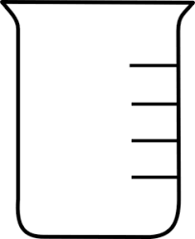
- Using the arrow seen below, illustrate the diffusion of molecules from high concentration to low concentration.

Equilibrium reached
Sugar molecules diffusing
Sugar cube in beaker

- What can affect the rate of diffusion?
- Predict: what would happen if you drop the sugar cube into a beaker of hot water vs. a beaker of cold water?
Link 3 – Facilitated Diffusion Tutorial
- What is facilitated diffusion?
- Explain what it means to say these protein channels are selective in what they allow into or out of the cell.
- Facilitated diffusion involves the movement of particles ( with / against ) the concentration gradient.
- In what ways are simple diffusion and facilitated diffusion the same?
- How are they different?
- Use the space to the right to draw the facilitated diffusion of larger molecules, such as glucose, across the cell membrane.
Link 4 – Osmosis Review
- In a solution (liquid mixture)
  - The ______________________________ is being dissolved
  - The ______________________________ is doing the dissolving (typically water!)
- Define osmosis.
- Osmosis is a type of PASSIVE transport because water moves from a __________ __________ concentration.
- What does it mean to say the cell membrane is selectively permeable?
- Complete the table on the three osmotic conditions.
Isotonic Solution | Hypertonic Solution | Hypotonic Solution
The concentration of solute inside and outside the cell are _________________.  What happens to the cell in an isotonic solution?  Real life example: | The concentration of solute outside the cell is ________________ than inside the cell.  What happens to the cell in an hypertonic solution?  Real life example: | The concentration of solute outside the cell is ________________ than inside the cell.  What happens to the cell in an hypotonic solution?  Real life example:

Link 5 – Osmosis Scenarios
- Scroll to the bottom & drop the cell into the solutions. Draw & describe what happens to the cell in each beaker.

Animal Cell .85% solute concentration
Dropped in 0% salt solution (distilled water)
What happened to the cell?

What type of SOLUTION is this?
Animal Cell .85% solute concentration
Dropped into .85% salt solution
What happened to the cell?

What type of SOLUTION is this?
Animal Cell .85% solute concentration
Dropped in 5.0% salt solution
What happened to the cell?

What type of SOLUTION is this?

PASSIVE VS ACTIVE TRANSPORT REVIEW
Use your notes and/or textbook to fill in the following:
Energy required? Yes or No
Molecules move from
_____ _____
( with / against ) gradient
Examples: Endocytosis and Exocytosis
Passive Transport
Active Transport
Movement of materials in and out of the cell
Utilizes the cell membrane
Needed to maintain homeostasis within
the cell
Energy required? Yes or No
Molecules move from
_____ _____
( with / against ) gradient
Examples: Diffusion, Osmosis, Facilitated Diffusion

Link 6 – Endocytosis and Exocytosis
- Endocytosis is the active transport of food and large materials ( into / out of ) the cell.
- Ilustrate the process of endocytosis.

Middle
End
Beginning

- Exocytosis is the active transport of food and large materials ( into / out of ) the cell.
- Illustrate the process of exocytosis.
Middle
End
Beginning

